PREPAID
LOGIC MANUAL

Created By Hendra Wijaya
Created On 26/05/2010

Table Structure

No | Table Name
1 | MigrasiPP
2 | PP_AccountMaster
3 | PP_Amortization
4 | PP_BankBranch
5 | PP_BankMaster
6 | PP_CostCenterMaster
7 | PP_Journal_Dtl
8 | PP_Journal_Dtl_Temp_Prepaid
9 | PP_Journal_Dtl_Temp_Termination
10 | PP_Journal_Hdr
11 | PP_Period
12 | PP_Prepaid
13 | PP_PrepaidTypeMaster
14 | PP_Termination
15 | SYS_SourceOfDoc_Dtl
16 | SYS_SourceOfDoc_Hdr

Login

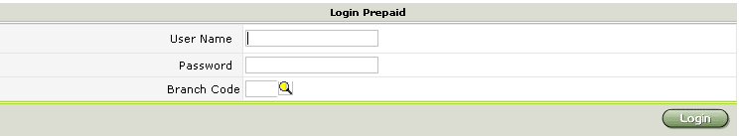

Account Browse

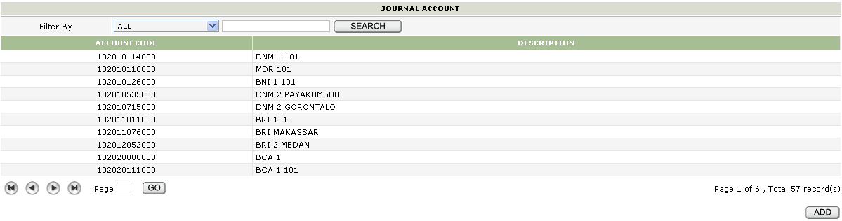

Search Filter
- Account Code
- Description

Hyperlink
- Account Code
  - Link ke Account Input

Button
- Add
  - Link ke Account Input

Account Input

Button
- New
  - Link ke Account Input
- Save
  - Insert data ke PP_AccountMaster
  - Link ke Account Browse
- Delete
  - Delete data dari PP_AccountMaster
  - Link ke Account Browse
- Back
  - Link ke Account Browse

Validation
    - Account Code tidak boleh kosong
    - Account Code harus berupa 12 digit angka
    - Description tidak boleh kosong

Cost Center Browse

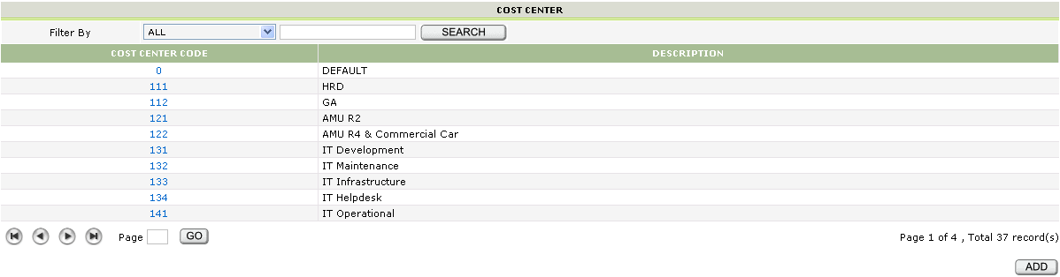

Search Filter
- Cost Center Code
- Description

Hyperlink
- Cost Center Code
  - Link ke Cost Center Input

Button
- Add
  - Link ke Cost Center Input

Cost Center Input

Button
- New
  - Link ke Cost Center Input
- Save
  - Insert data ke PP_CostCenterMaster
  - Link ke Cost Center Browse
- Delete
  - Delete data dari PP_CostCenterMaster
  - Link ke Cost Center Browse
- Back
  - Link ke Cost Center Browse

Validation
    - Cost Center Code tidak boleh kosong
    - Description tidak boleh kosong
Bank Browse

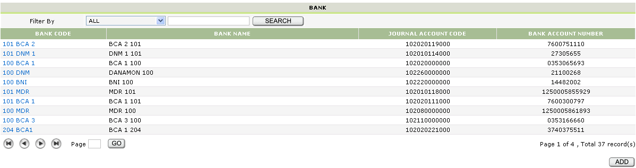

Search Filter
- Bank Code
- Bank Name

Hyperlink
- Bank Code
  - Link ke Bank Input

Button
- Add
  - Link ke Bank Input

Bank Input

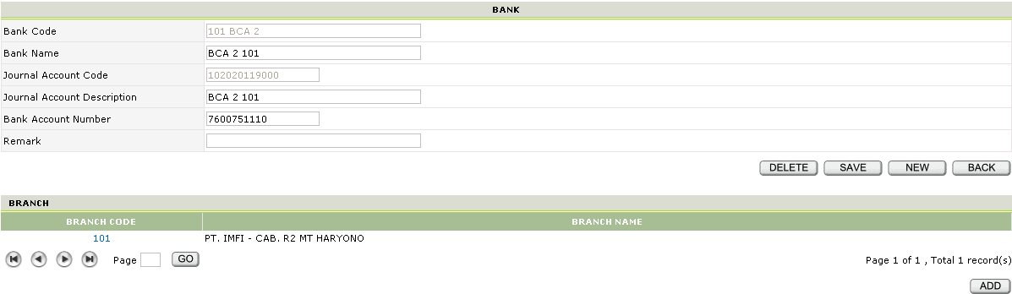

Hyperlink
- Branch Code
  - Link ke Bank Input Branch

Button
- New
  - Link ke Bank Input
- Save
  - Insert data ke PP_BankMaster
  - Link ke Bank Browse
- Delete
  - Delete data dari PP_BankMaster
  - Link ke Bank Browse
- Back
  - Link ke Bank Browse
- Add
  - Link ke Bank Input Branch

Validation
    - Journal Account Code tidak boleh kosong
    - Journal Account Description tidak boleh kosong
    - Bank Account Number tidak boleh kosong
    - Journal Account Code harus berupa 12 digit angka
    - Bank Account Number harus berupa angka
Bank Input Branch

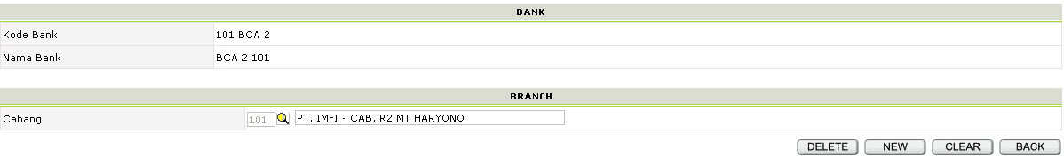

Button
- New
  - Link ke Bank Input Branch
- Clear
  - Link ke Bank Input Branch
- Save
  - Muncul jika menekan tombol Add dari halaman Bank Input
  - Insert data ke PP_BankBranch
  - Link ke Bank Input
- Delete
  - Muncul jika menekan hyperlink Branch Code dari halaman Bank Input
  - Delete data dari PP_BankBranch
  - Link ke Bank Input
- Back
  - Link ke Bank Input

Validation
    - Cabang harus dipilih, tidak boleh kosong

Type Browse

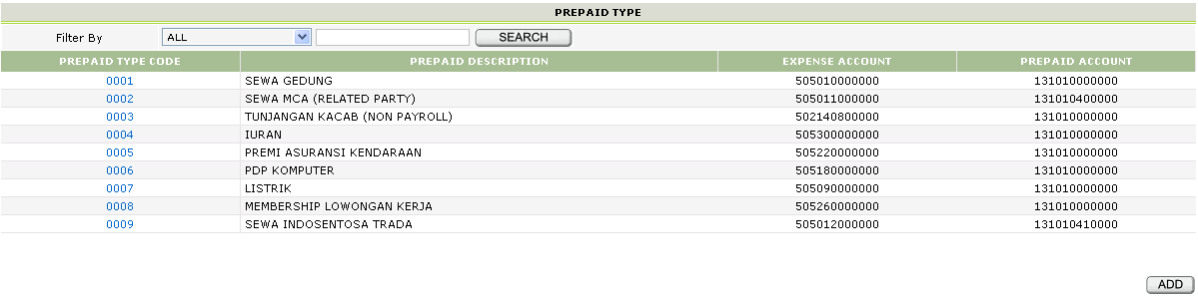

Search Filter
- Prepaid Type Code
- Prepaid Description

Hyperlink
- Prepaid Type Code
  - Link ke Type Input

Button
- Add
  - Link ke Type Input
Type Input

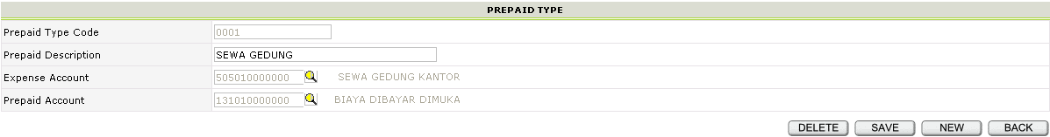

Button
- New
  - Link ke Type Input
- Save
  - Insert data ke PP_PrepaidTypeMaster
  - Link ke Type Browse
- Delete
  - Delete data dari PP_PrepaidTypeMaster
  - Link ke Type Browse
- Back
  - Link ke Type Browse

Validation
    - Prepaid Type Code tidak boleh kosong
    - Prepaid Description tidak boleh kosong
    - Expense Account tidak boleh kosong
    - Prepaid Account Code tidak boleh kosong
Prepaid Input

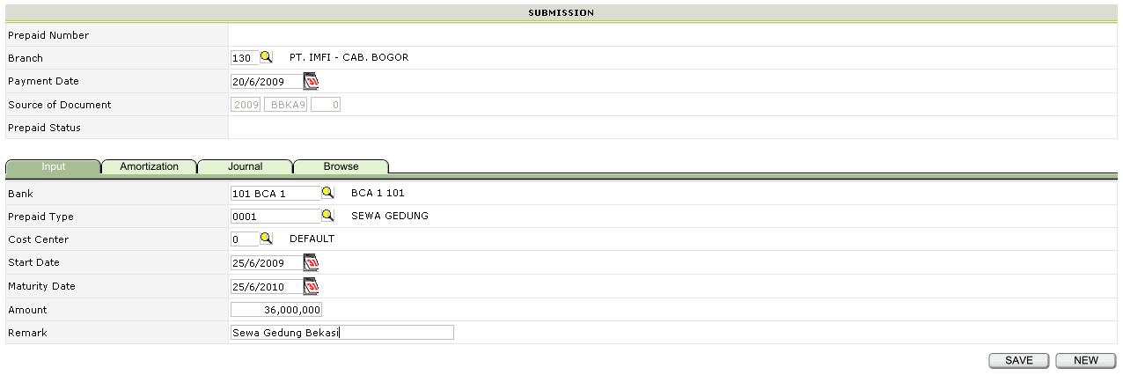

Button
- New
  - Link ke Prepaid Input
- Save
  - Insert data ke PP_Prepaid
  - Link ke Prepaid Input

Tabulation
- Amortization
  - Link ke Prepaid Amortization
- Journal
  - Link ke Prepaid Journal
- Browse
  - Link ke Prepaid Browse

Validation
- Prepaid Number, Source of Document, dan Status akan otomatis terisi
- Branch, Payment Date, Bank tidak boleh kosong
- Prepaid Type, Cost Center, Start Date, Maturity Date, dan Remark tidak boleh kosong
- Payment Date, Start Date, dan Maturity Date harus diisi dengan format dd/MM/yyyy
- Amount harus berupa angka
Prepaid Amortization

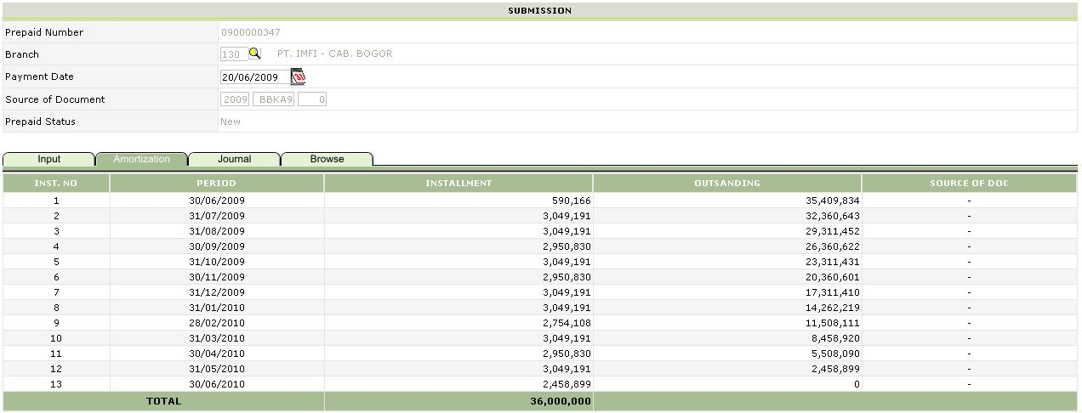

Tabulation
- Input
  - Link ke Prepaid Input
- Journal
  - Link ke Prepaid Journal
- Browse
  - Link ke Prepaid Browse
Prepaid Journal

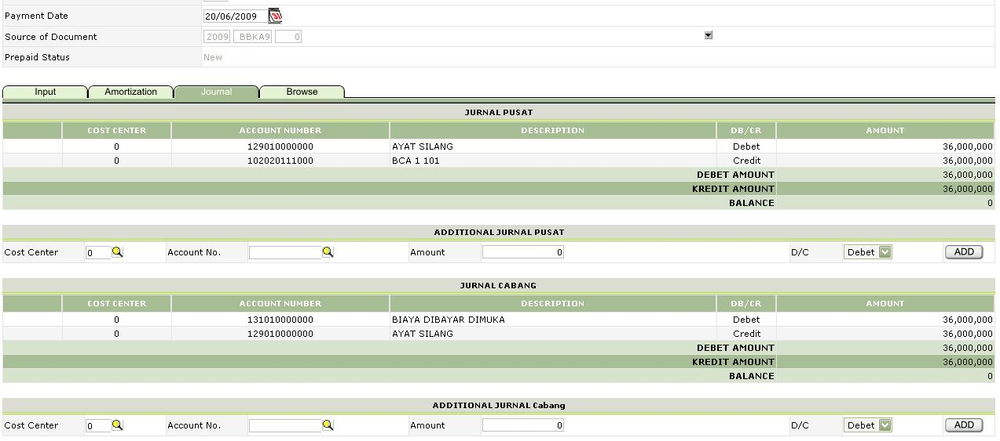

Button
- Add
  - Insert data ke PP_Journal_Dtl_Temp_Prepaid
  - Link ke Prepaid Journal

Tabulation
- Input
  - Link ke Prepaid Input
- Amortization
  - Link ke Prepaid Amortization
- Browse
  - Link ke Prepaid Browse

Prepaid Browse

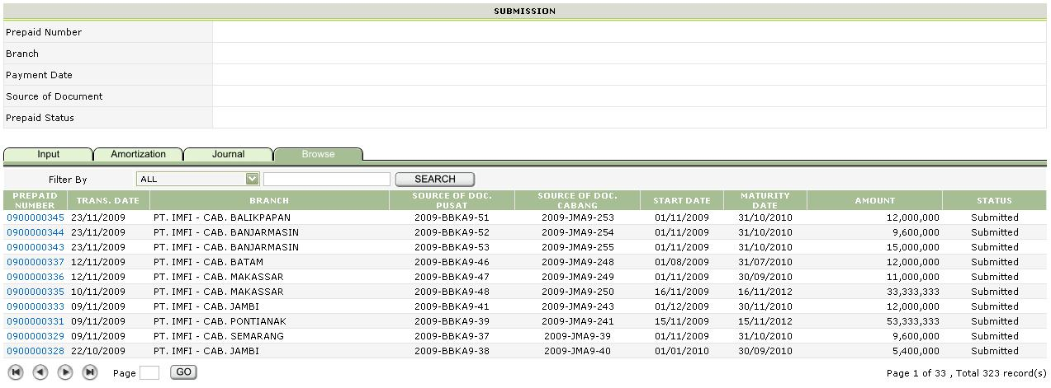

Search Filter
- Prepaid Number
- Branch
- Status

Hyperlink
- Prepaid Number
  - Link ke Prepaid Input

Tabulation
- Input
  - Link ke Prepaid Input
- Amortization
  - Link ke Prepaid Amortization
- Journal
  - Link ke Prepaid Journal
Termination Input

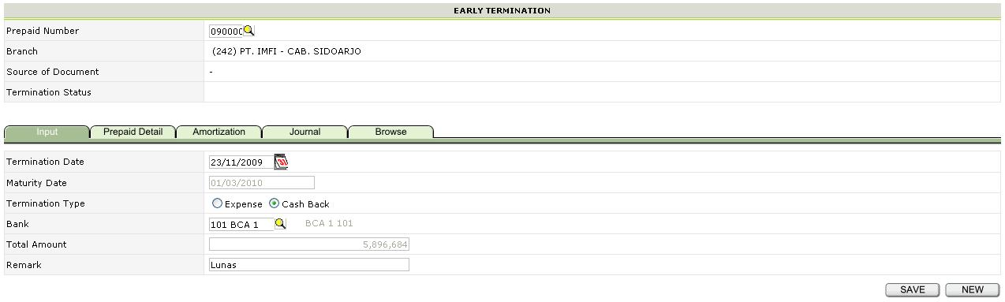

Button
- New
  - Link ke Termination Input
- Save
  - Insert data ke PP_Termination
  - Link ke Termination Input

Tabulation
- Prepaid Detail
  - Link ke Termination Prepaid Detail
- Amortization
  - Link ke Termination Amortization
- Journal
  - Link ke Termination Journal
- Browse
  - Link ke Termination Browse

Validation
- Prepaid Number harus dipilih, tidak boleh kosong
- Branch, Source of Document, dan Termination Status akan otomatis terisi
- Termination Date harus diisi dengan format dd/MM/yyyy
- Maturity Date dan Total Amount akan otomatis terisi
- Bank harus dipilih, tidak boleh kosong
- Remark tidak boleh kosong
Termination Prepaid Detail

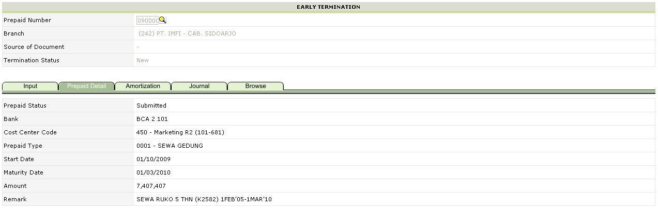

Tabulation
- Input
  - Link ke Termination Input
- Amortization
  - Link ke Termination Amortization
- Journal
  - Link ke Termination Journal
- Browse
  - Link ke Termination Browse
Termination Amortization

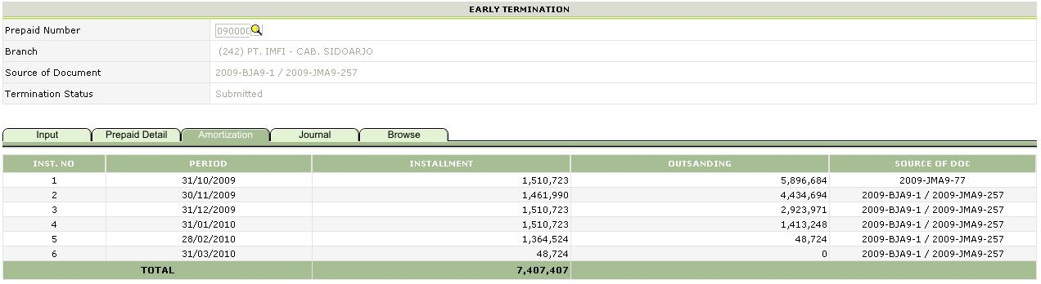

Tabulation
- Input
  - Link ke Termination Input
- Prepaid Detail
  - Link ke Termination Prepaid Detail
- Journal
  - Link ke Termination Journal
- Browse
  - Link ke Termination Browse
Termination Journal

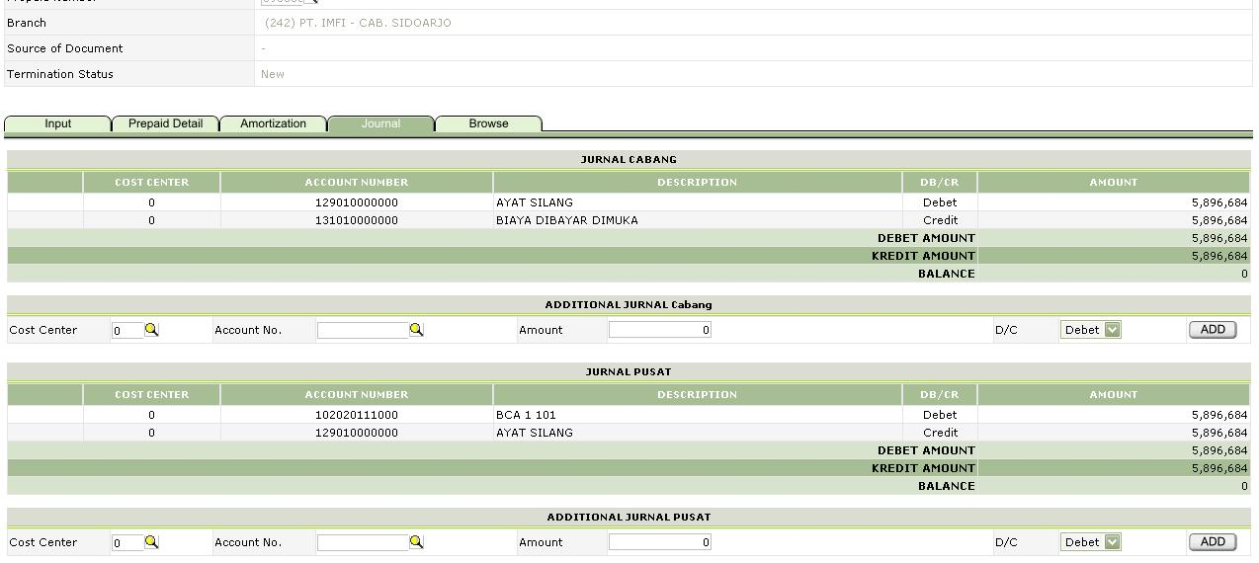

Button
- Add
  - Insert data ke PP_Journal_Dtl_Temp_Termination
  - Link ke Termination Journal

Tabulation
- Input
  - Link ke Termination Input
- Prepaid Detail
  - Link ke Termination Prepaid Detail
- Amortization
  - Link ke Termination Amortization
- Browse
  - Link ke Termination Browse

Termination Browse

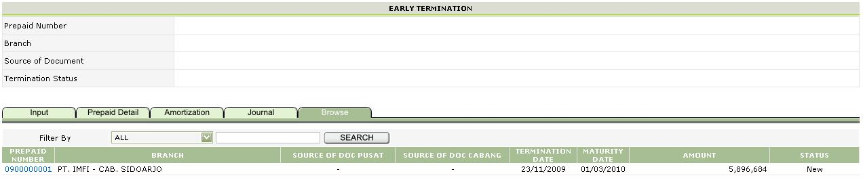

Search Filter
- Prepaid Number
- Branch

Hyperlink
- Prepaid Number
  - Link ke Termination Input

Tabulation
- Input
  - Link ke Termination Input
- Prepaid Detail
  - Link ke Termination Prepaid Detail
- Amortization
  - Link ke Termination Amortization
- Journal
  - Link ke Termination Journal
Monthly

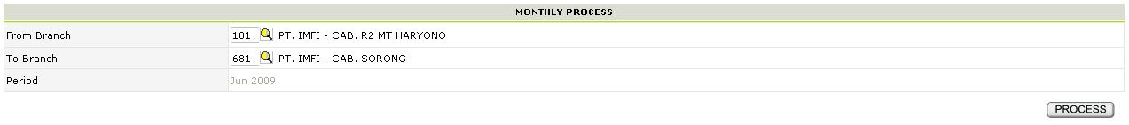

Button
- Process
  - (database)
  - Link ke Monthly

Validation
- Period akan otomatis terisi
- From Branch dan To Branch harus dipilih, tidak boleh kosong
Transfer GL

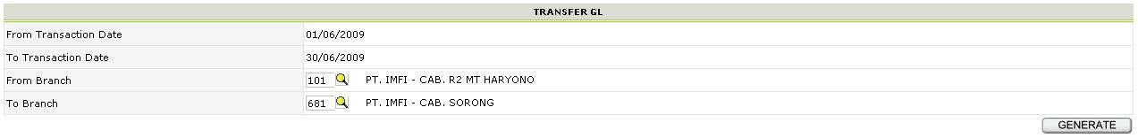

Button
- Generate
  - (database)
  - Link ke TransferGL

Validation
- From Transaction Date dan To Transaction Date akan otomatis terisi
- From Branch dan To Branch harus dipilih, tidak boleh kosong
Close Period

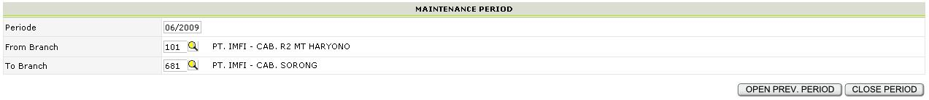

Button
- Open Prev. Period
  - (database)
  - Link ke Close Period
- Close Period
  - (database)
  - Link ke Close Period

Validation
- Periode akan otomatis terisi
- From Branch dan To Branch harus dipilih, tidak boleh kosong

